GOVERNMENT POLYTECHNIC PUNE
(An Autonomous Institute of Government of Maharashtra)
Third Year diploma in Computer Engineering
Academic Year 2026-27


A Micro project Report on
Title:
“SecureVault – Secure File Encryption and Decryption System. Submitted by :
Srushti Gaikwad | 2406056
Vaishnavi Hambarde | 2406066
Anuja Hangarge | 2406068

Under the guidance of:
Mrs. A.S.Paike
GOVERNMENT POLYTECHNIC PUNE
(An Autonomous Institute of Government of Maharashtra)
Third Year diploma in Computer Engineering
Academic Year 2026-27
CERTIFICATE
This is certified that micro project work entitled “Cyber Security" is a Bonafide work carried out by:-
Srushti Gaikwad | 2406056
Vaishnavi Hambarde | 2406066
Anuja Hangarge | 2406068
Has successfully completed the micro project title "Cloud-Based Student Result Management System” as a partial fulfilment of requirements of Fifth Semester of Third Year Diploma in Computer Engineering for the academic year 2026-2027.

Mrs. A.S.Paike Mrs. J R. Hange Mr.Dr.R.K. Patil
(Guide) (Head Of Department) (Principal)
- ACKNOWLEDGEMENT

In today's digital world, a large amount of information is stored and exchanged in the form of digital files. These files may contain personal, educational, financial, business, or confidential information. Unauthorized access to such files can lead to data leakage, privacy problems, and misuse of information. Therefore, protecting digital files has become an important requirement.
SecureVault is a secure file encryption and decryption system developed to protect digital files from unauthorized access. The system uses encryption techniques to convert readable file data into an unreadable encrypted format. The encrypted file can only be converted back into its original form by using the appropriate decryption key.
The proposed system provides two main operations: Encryption and Decryption. During encryption, the selected file is processed using a cryptographic technique and stored in a protected form. During decryption, the encrypted file is processed using the correct key to recover the original file.
SecureVault aims to provide a simple, user-friendly, and efficient solution for basic file security. It demonstrates the practical application of cryptography and data protection techniques.

- INTRODUCTION
Information security is one of the most important requirements in modern computing. Computers and mobile devices store a large amount of important information in the form of documents, images, videos, PDFs, text files, and other digital formats.
If these files are stored without protection, unauthorized users may be able to access them. This can create serious privacy and security issues.
Encryption is one of the fundamental techniques used to protect information. Encryption converts readable data, called plaintext, into an unreadable form called ciphertext. The ciphertext can be converted back into plaintext using a suitable decryption process.
SecureVault is designed based on this concept. It provides a simple interface through which a user can select a file, provide a security key, encrypt the file, and later decrypt it when required.
The project helps demonstrate how cryptography can be applied to real-world file security.

- Objective of the Project
The main objective of SecureVault – Secure File Encryption and Decryption System is to develop a secure and user-friendly system for protecting digital files from unauthorized access.
The specific objectives are:
To provide a secure method for encrypting digital files.
To allow authorized users to decrypt and recover original files.
To protect sensitive and confidential information from unauthorized access.
To implement cryptographic techniques for file security.
To provide a simple and easy-to-use Graphical User Interface (GUI).
To ensure that encrypted files cannot be easily understood without the correct security key.
To demonstrate the practical application of encryption and decryption.
To reduce the risk of data leakage and unauthorized file access.
To provide a reliable method for securing important documents and files.
To understand the importance of data confidentiality and information security in real-world applications

- Background of the Project
Digital technology has increased the use of electronic storage. Important files are stored on computers, laptops, USB drives and cloud storage.
Examples include:
College documents
Project reports
Personal documents
Business files
Financial records
Research documents
Important PDFs
Simply storing a file does not guarantee its security. Encryption provides an additional layer of protection so that unauthorized users cannot easily understand the protected data.

- Problem Statement
Digital files can be accessed, copied or misused by unauthorized users when proper security is not provided.
- Therefore, there is a need for a system that can:
- Select and encrypt files.
- Store files in protected form.
- Protect encrypted data using a security key.
- Decrypt files only for authorized users.
- Restore the original file accurately.
Problem Statement:
“To design and develop a secure file encryption and decryption system that protects digital files from unauthorized access using cryptographic techniques.”

- Aim of the Project
The main aim of SecureVault is to develop a simple and secure application that allows users to encrypt and decrypt digital files using cryptographic techniques.
- The project focuses on:
- File confidentiality
- Secure storage
- Controlled access
- Data protection
- Simple user interaction

- Scope of the Project
SecureVault can be used for secure handling of different digital files through encryption and decryption.
- The system can be used for:
- Personal file protection
- Student project files
- Office documents
- Confidential text files
- Educational records
- Important PDFs and images
In the future, the system can be extended with cloud storage, multi-user authentication and secure file sharing.
- Existing System
In a conventional file storage system, files are stored directly on a computer or storage device.
Problems
Unauthorized users may access files.
Sensitive information may be exposed.
Files can be copied easily.
Confidential information may be misused.
There may be no additional encryption layer.
- Proposed System
SecureVault provides an additional security layer using encryption.
The user selects a file and enters the required security key. The system encrypts the file and creates a protected version. To recover the original file, the user selects the encrypted file and provides the correct key.
Encryption:
Original File → Encryption → Encrypted File
Decryption:
Encrypted File → Decryption → Original File
10. System Architecture
User
↓
Graphical User Interface
↓
File Selection
↓
Encryption / Decryption Module
↓
Cryptographic Algorithm
↓
Secure File Storage
The user interacts with the system through the GUI, and the selected file is processed by the appropriate encryption or decryption module.
- System Modules
- User Interface Module
- Provides interaction between the user and the system. It includes file selection, encryption, decryption and key/password options.
- File Selection Module
- Allows the user to select the file that needs to be encrypted or decrypted.
- Encryption Module
- Converts readable file data into encrypted data and saves the protected file. Decryption Module
- Converts encrypted data back into its original form using the correct key.
- Key Management Module
- Handles the security key required for encryption and decryption.
- File Storage Module
- Manages the storage of encrypted and decrypted files at the required location.
- Encryption
- Encryption is the process of converting readable information into an encoded form.
- Plaintext → Encryption + Key → Ciphertext
- The original readable information is called plaintext

- Technologies Used
- Technology
- Purpose
- Python
- Application development
- Tkinter
- Graphical User Interface
- Cryptography
- Encryption and Decryption
- File Handling
- Reading and writing files
- VS Code
- Development

- Algorithm – Encryption

- Start the application.
- Select the input file.
- Enter the security key.
- Read the file data.
- Apply the encryption algorithm.
- Generate encrypted data.
- Save the encrypted file.
- Display the success message.
- Stop.

- Algorithm – Decryption
- Start the application.
- Select the encrypted file.
- Enter the security key.
- Read the encrypted data.
- Apply the decryption algorithm.
- Generate the original data.
- Save the decrypted file.
- Display the success message.
- Stop.

- Data Flow
Basic Flow
User → SecureVault → Encrypted/Decrypted File
Detailed Flow
User
↓
Select File
↓
Enter Key
↓
Choose Operation
↓
Encrypt / Decrypt
↓
Output File

- Advantages
- Easy to use.
- Protects confidential files.
- Provides file-level security.
- Supports encryption and decryption.
- Reduces unauthorized access.
- Demonstrates practical use of cryptography.
- Provides an additional layer of data protection.

- Limitations
- Security depends on proper key management.
- User must remember the correct key.
- Large files may require more processing time.
- Basic version may not include advanced authentication.
- It may not protect against every type of cyberattack.

- Applications
- SecureVault can be used in:
- Educational institutions
- Personal computers
- Small businesses
- Office environments
- Project file protection
- Confidential document storage
- Research data protection

- Future Scope
- The project can be further improved by adding:
- Cloud-based file encryption
- Two-factor authentication
- Biometric authentication
- Multi-user login
- Secure file sharing
- Password strength checking
- File integrity verification
- Mobile application
- Web-based version
- Activity logs

- Output
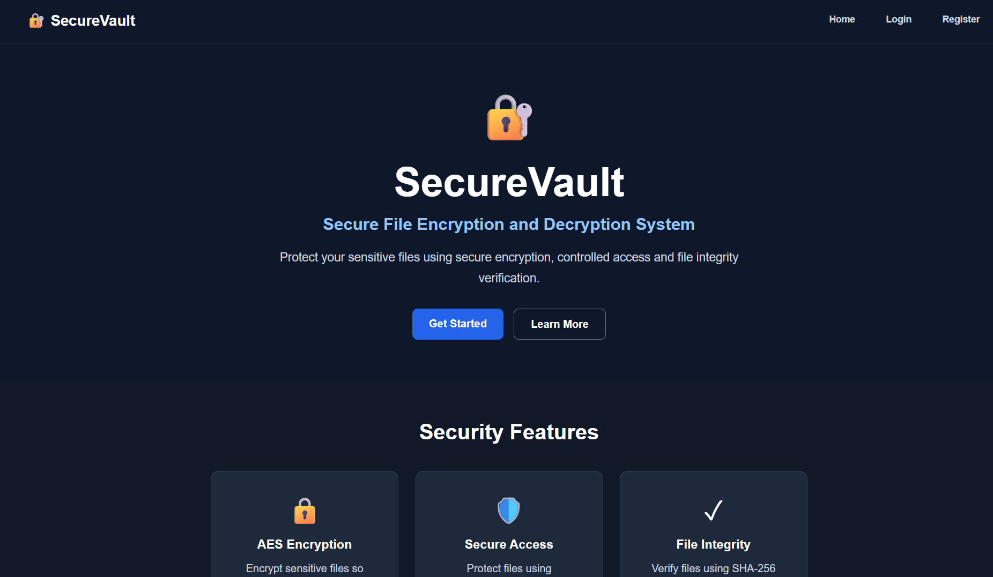
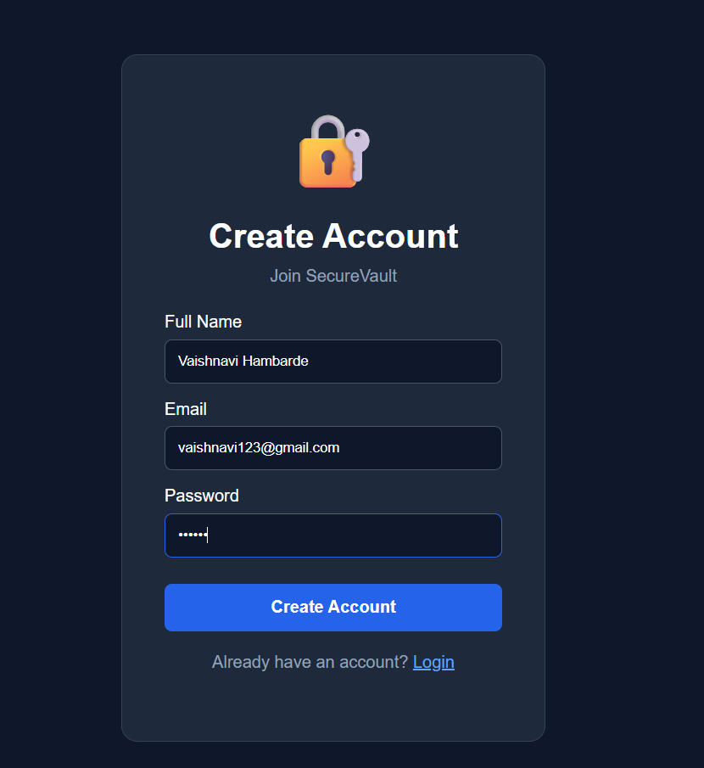
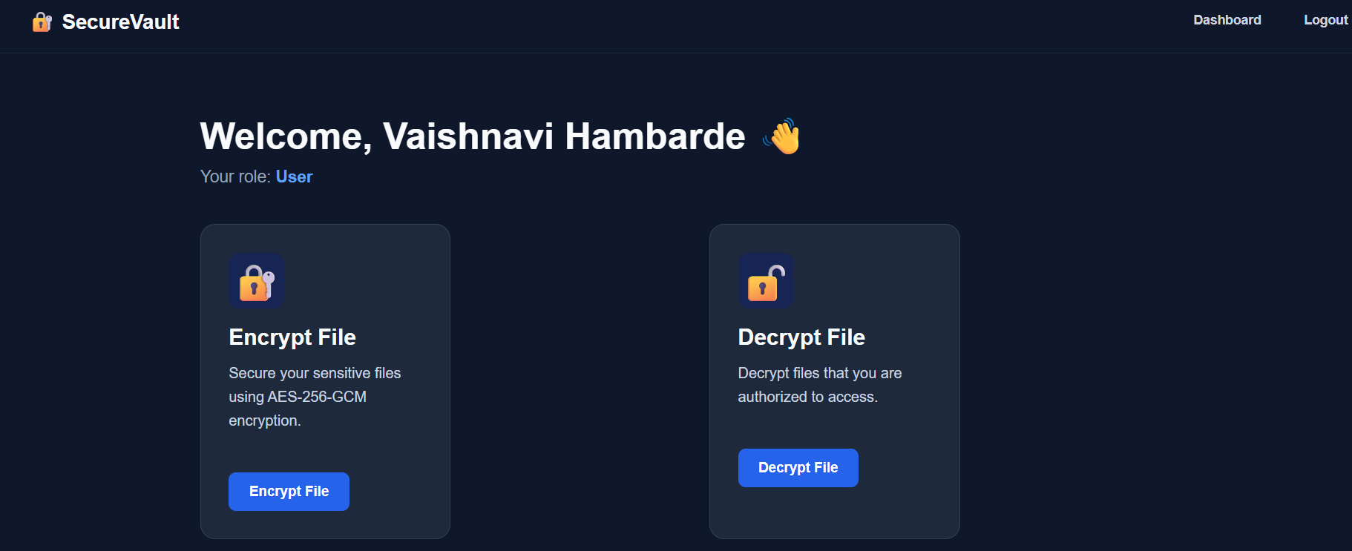
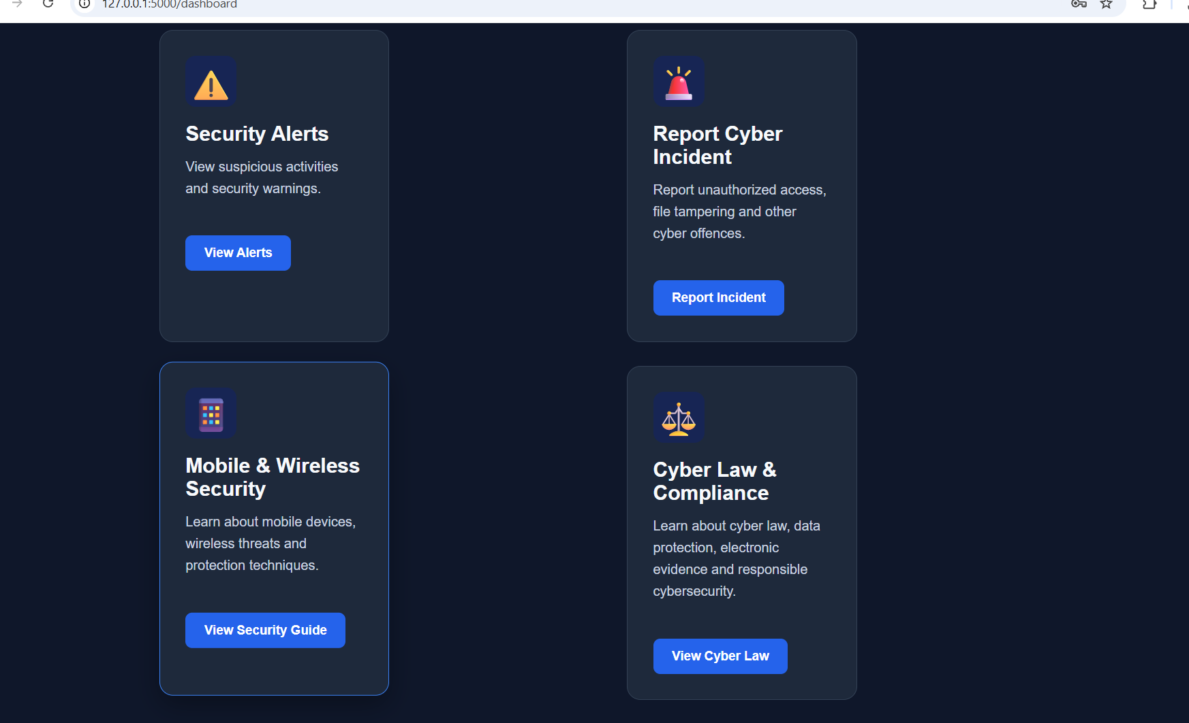
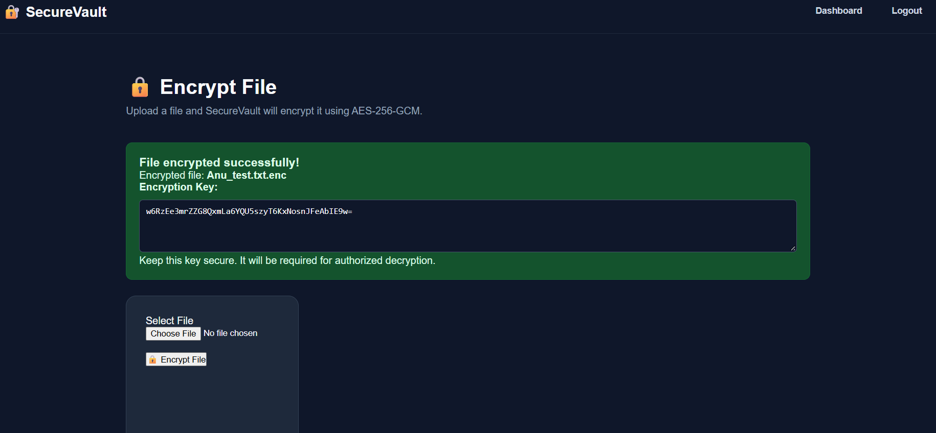
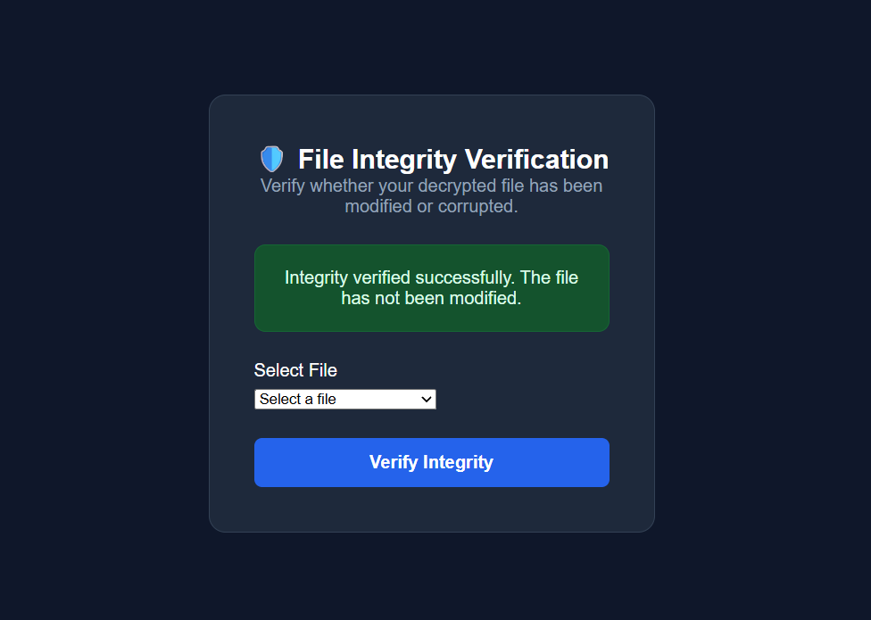
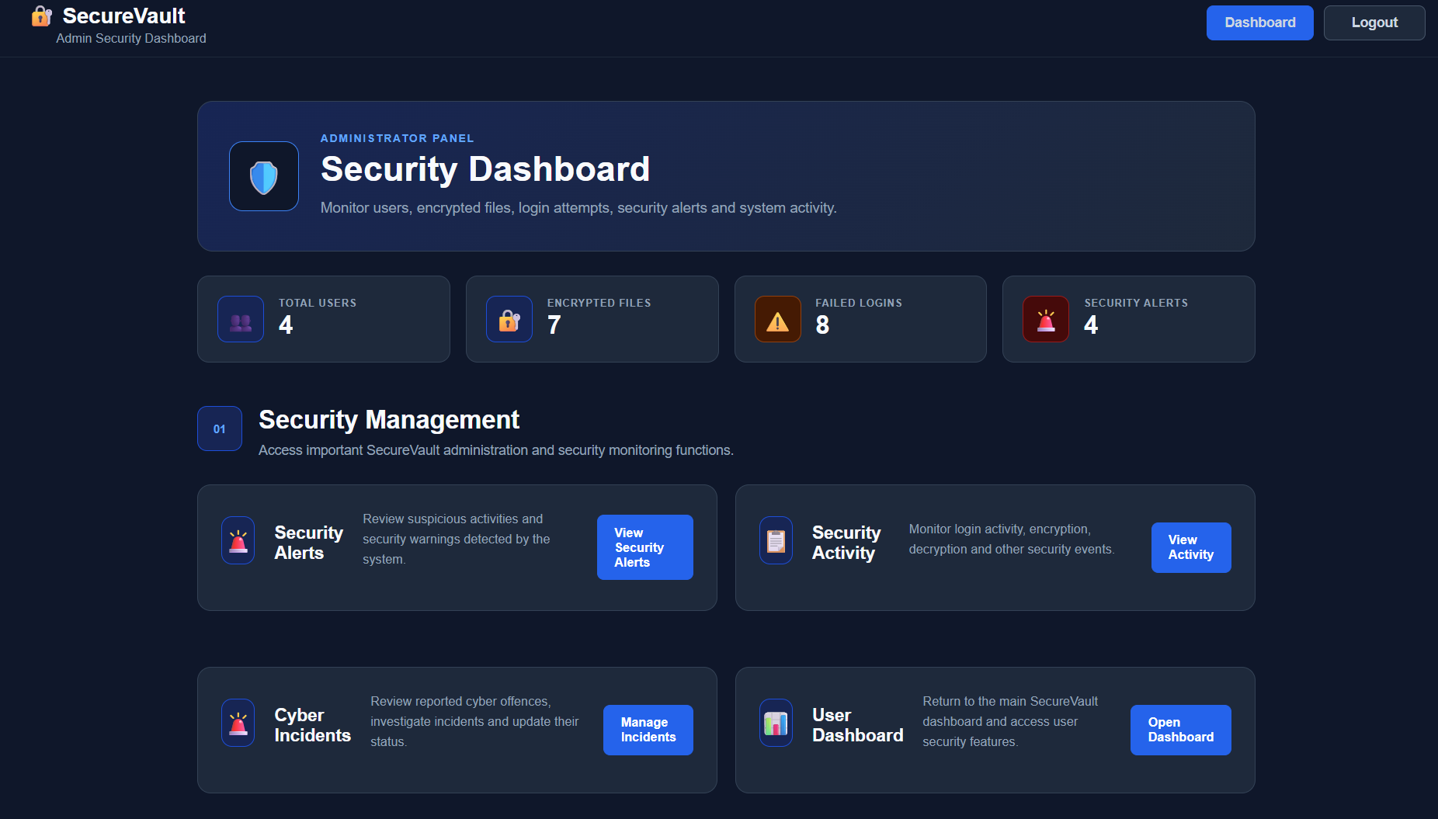
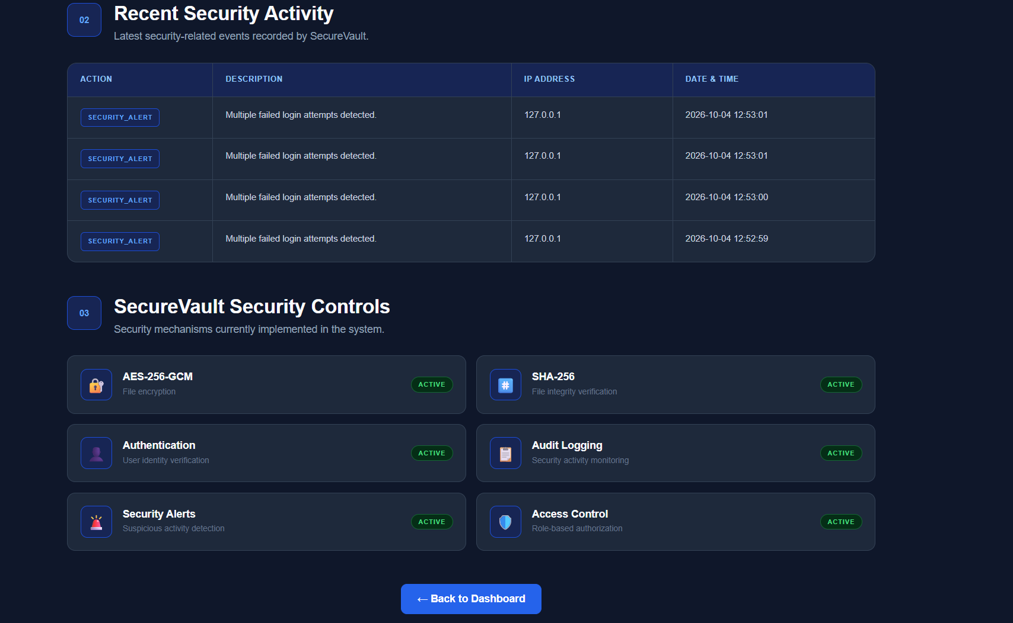

- Conclusion
SecureVault is a secure file encryption and decryption system developed to protect digital files from unauthorized access. The system uses cryptographic techniques to convert readable file data into an encrypted format, making the information difficult to access without the correct security key. Authorized users can decrypt the protected file and restore it to its original form.
The project provides a simple, user-friendly and efficient approach to file security. It demonstrates important concepts such as encryption, decryption, cryptography, data confidentiality, secure storage and key management. SecureVault can be useful for protecting personal documents, educational files, office documents and other confidential information.
Overall, this project helps in understanding the practical importance of information security in the digital world. In the future, SecureVault can be enhanced by adding cloud storage, two-factor authentication, biometric authentication, secure file sharing and advanced encryption techniques, making the system more secure and suitable for real-world applications.

---------------------------------------Thank You..!!-------------------------------------

